HW 1: Ansible

1. Install Ansible on your system using a package manager of your choice, pip or brew

Command: **brew install ansible**

I have created two AWS EC2 instances, the first one VM1 and the second one VM2.

To create these instances, I used Ansible aws resources (aws.ec2_instace), in the process of creating these instances, I had to create a private key and a security group, which I used to create the EC2 instance. The code for deploying these resources can be found in the file deployserver.yml, Screenshot of the deployserver.yml below

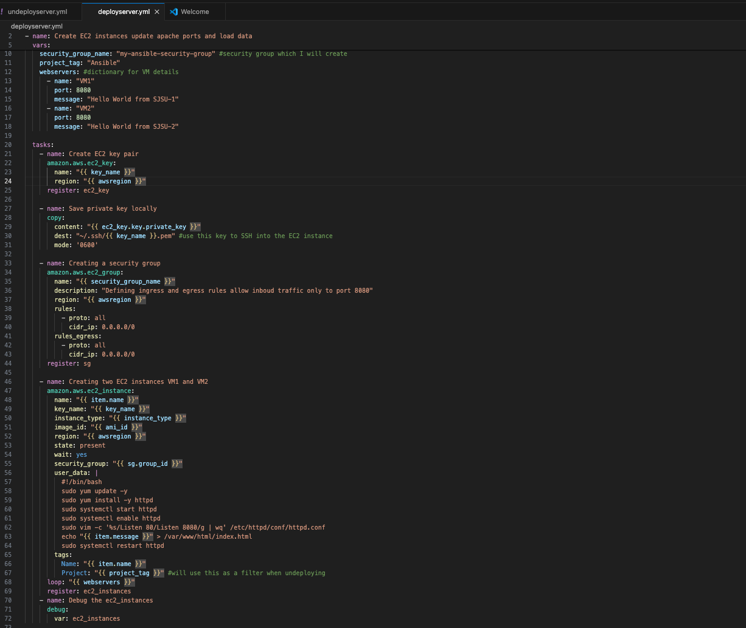

A bit about the code in here I am creating 2 new EC2 instances called VM1 and VM2, on each one of these instances, I am installing Apache and changing the port from default 80 to 8080, these commands are being passed in through the user data property.

To deploy the changes I used the command ansible-playbook **deployserver.yml**The output for the command was as shown below you can see the instances i-0ab69d3c3698c6fba (VM2)and i-0c15c15408d310263(VM1) are created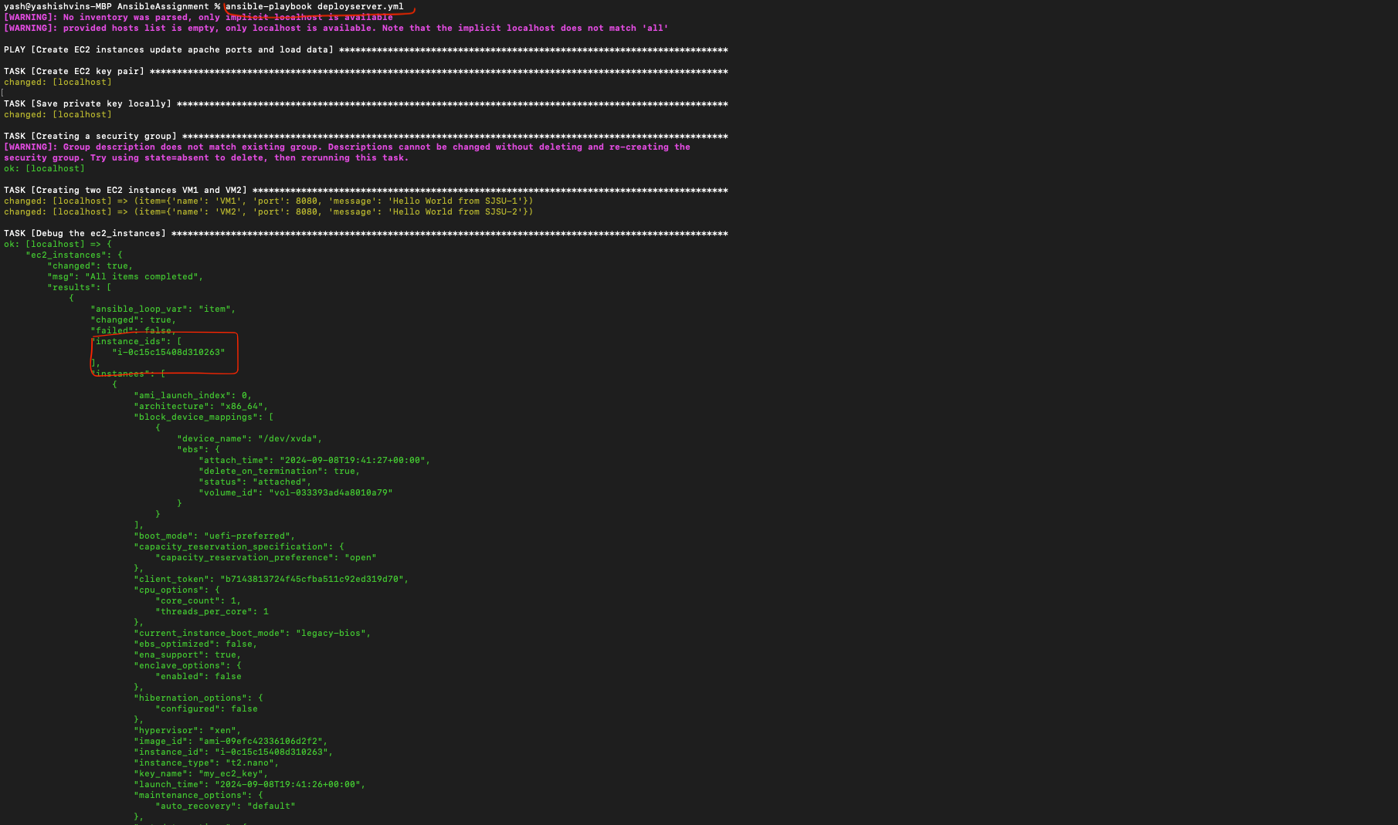

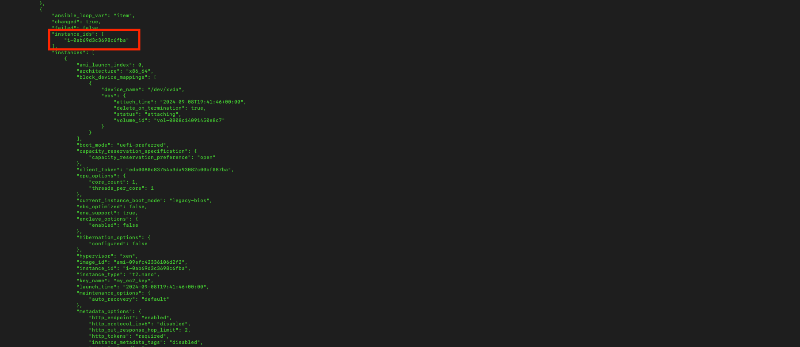

Details and Instance ID’s of VMs created on AWS console

**VM01 details**

**INSTANCE ID: i-0c15c15408d310263**(VM1)

**PUBLIC IP: 18.189.195.204**

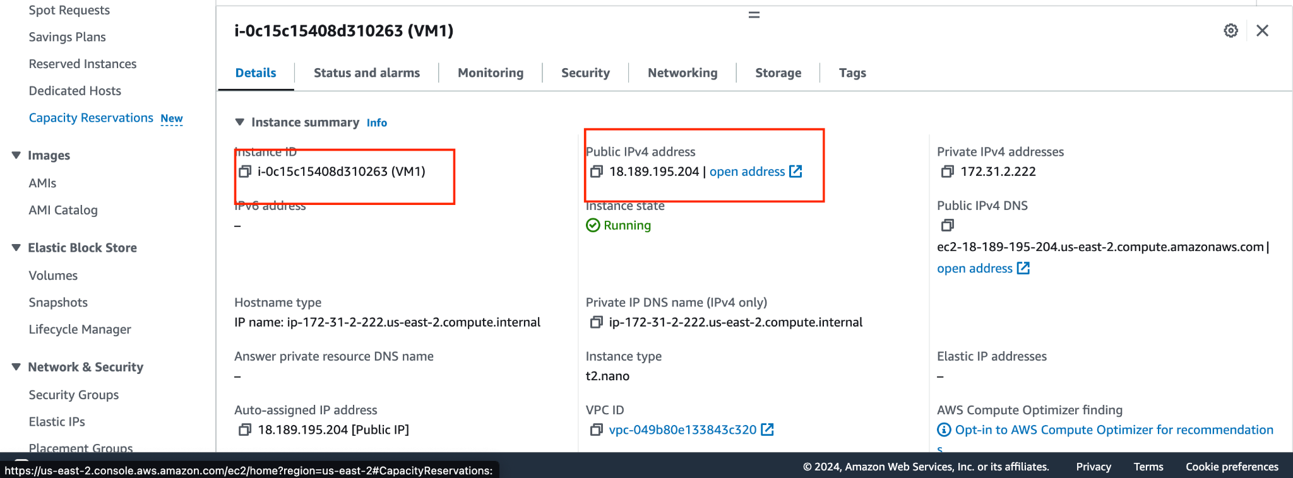

**VM02 details**

**INSTANCE ID:i-0ab69d3c3698c6fba**

**PUBLIC IP:18.222.57.4**

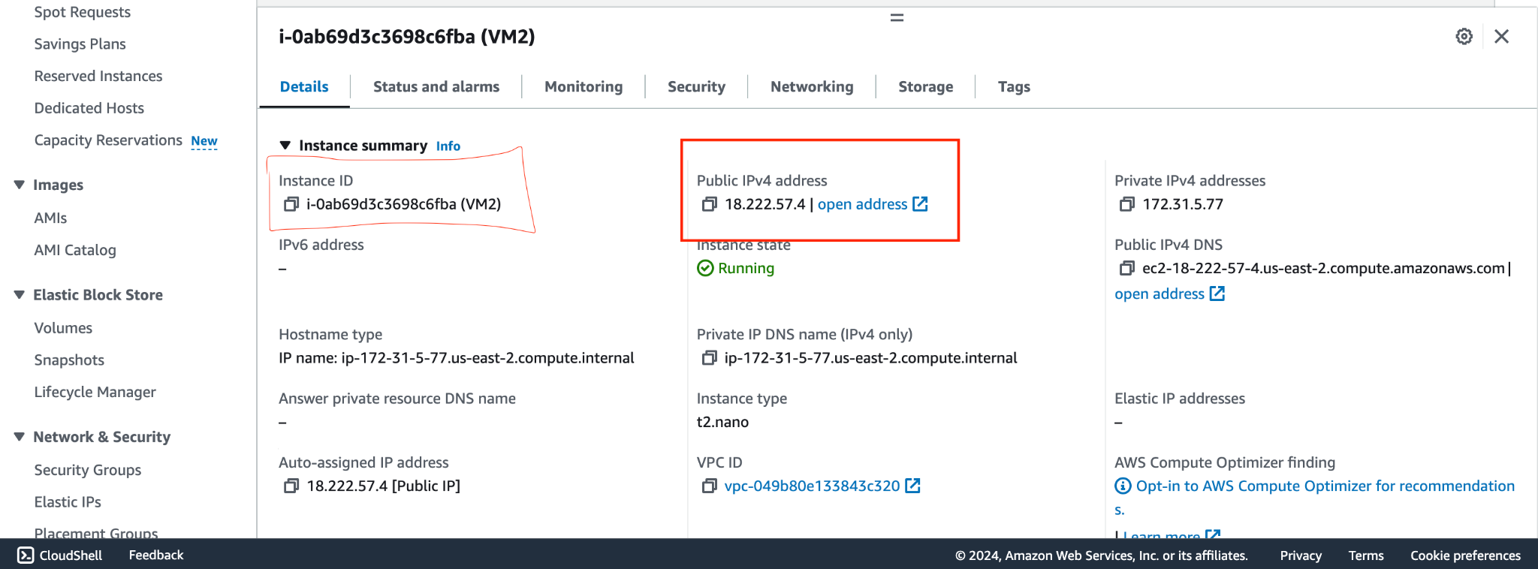

**Accessing the webservers from the browser**

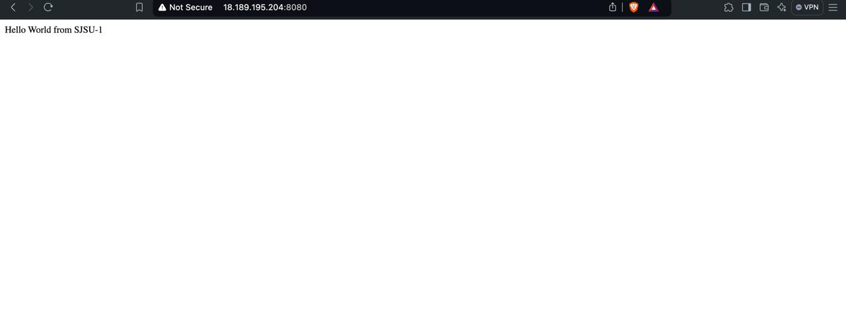

**Accessing VM01 from the browser**

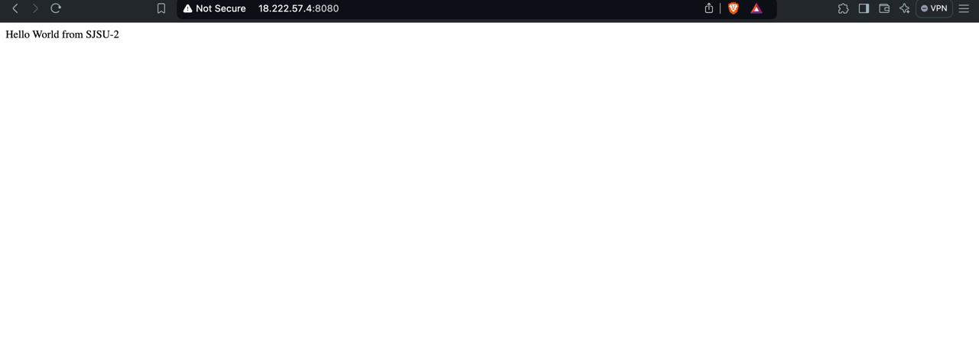

**Accessing VM02 from the browser**

**Destroying/Undeploying our resources**

The code for undeploying the resources goes into the file undeployserver.yml, in here I am terminating EC2 instances whose tag matches the region and project filter tag(Ansible).

Code for undeployserver.yml

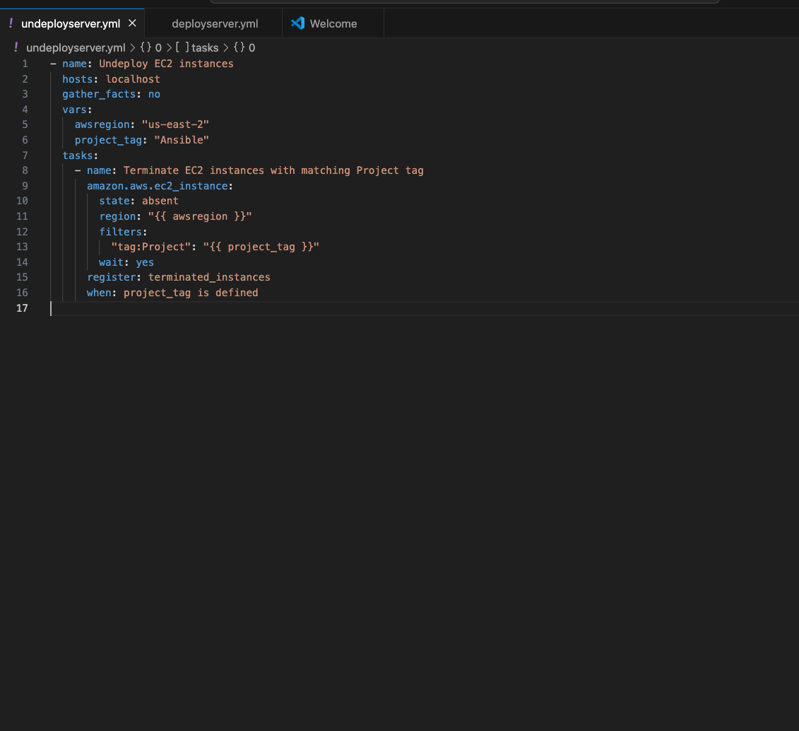

To destroy/undeploy the resources I ran **ansible-playbook undeployserver.yml**

**The output of the command is as follows.**

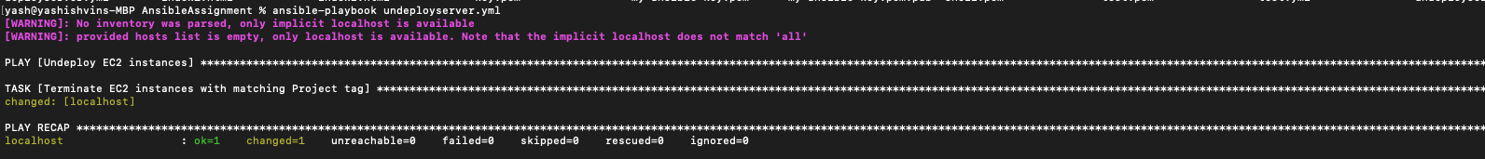

**The EC2 were destroyed and can be seen they were terminated as shown below**

1. **VM01 after termination**

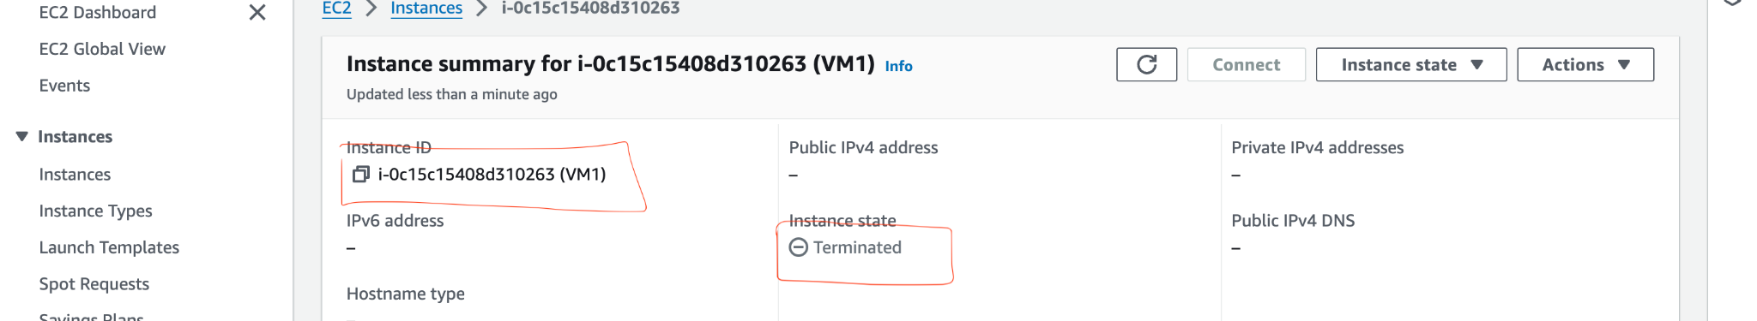

1. **VM02 after termination**

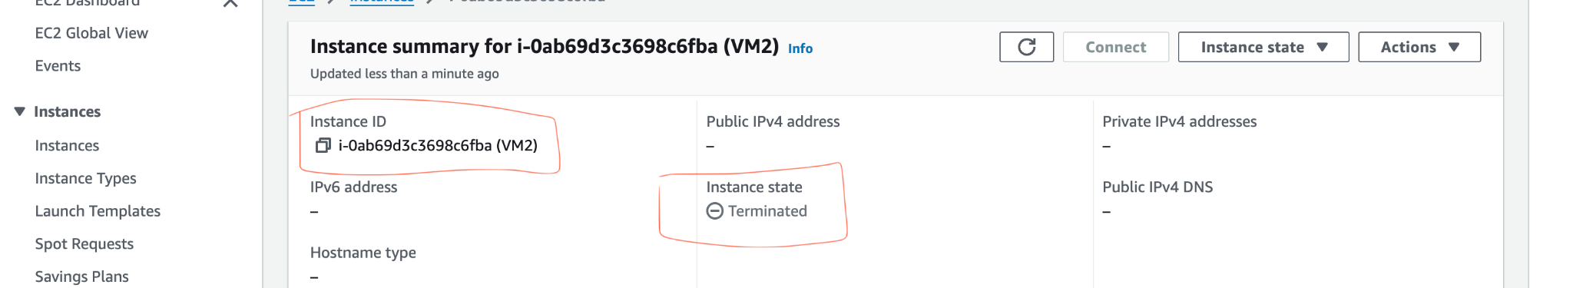

**Security group on AWS console**

